Validation
Please follow the below examples to validate that you have successfully installed the Vertex cartridge.

Business Manager:
Vertex has basic functionality tests available in business manager. Go to Merchant Tools > VertexInc. Two buttons will be placed in left side of menu.
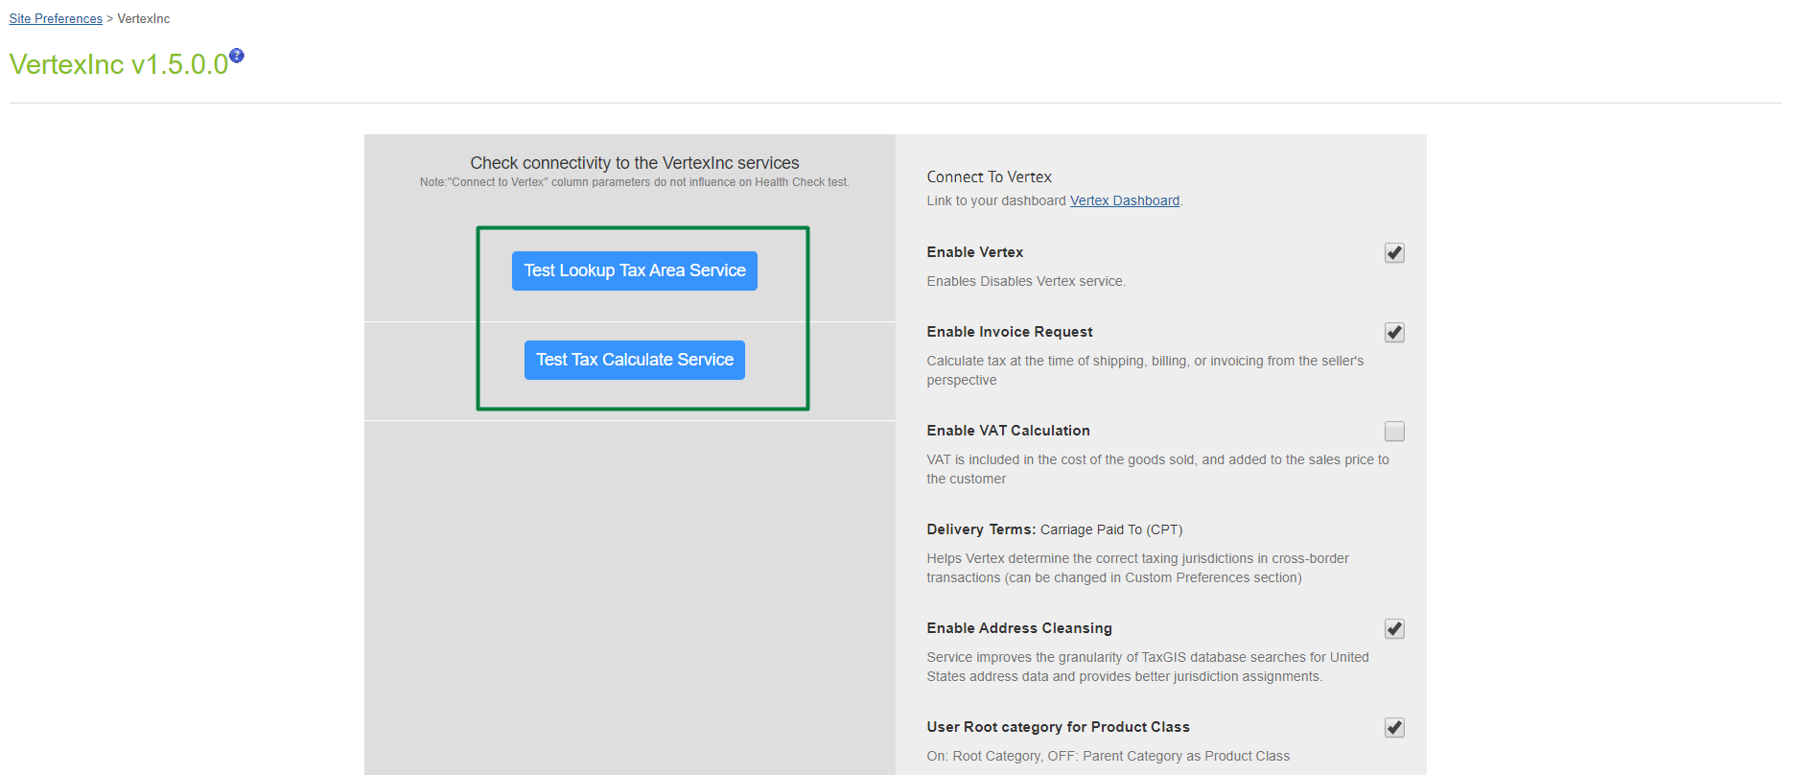

After launching a test button you’ll see a result notification.
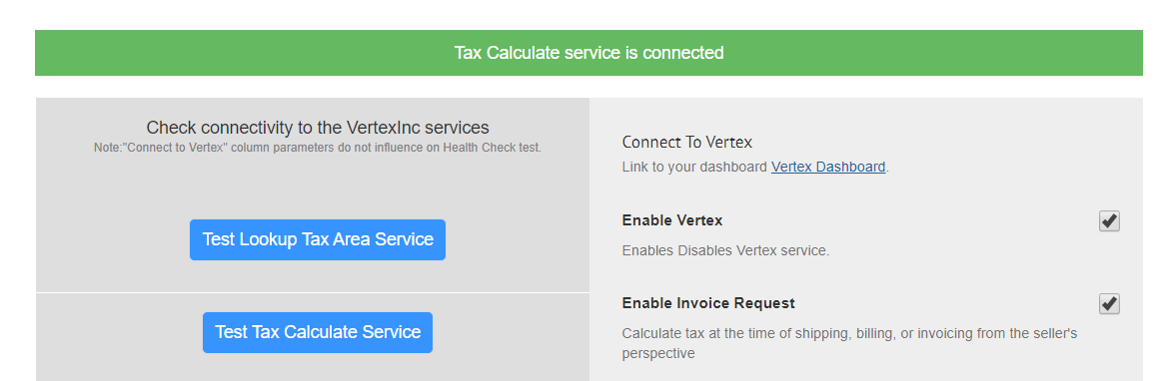

Go to Administration > Services

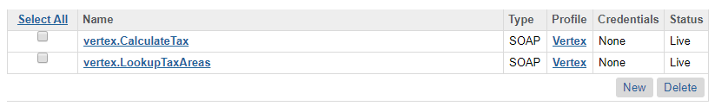

Click on each service and allow to write messages in log
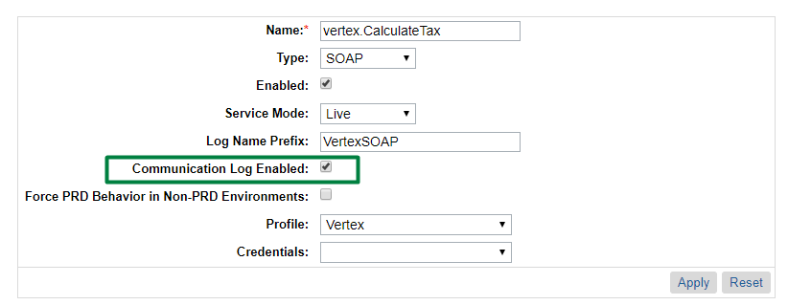

Go to Administration > Custom log service
Set log granularity to DEBUG level
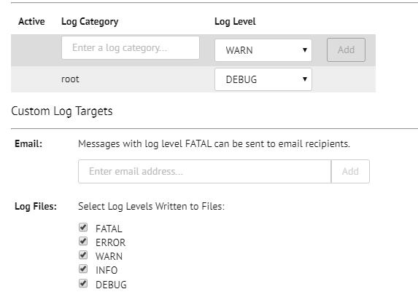

Go to a store, add any product to cart and start checkout process. Put some invalid data into shipping address form.
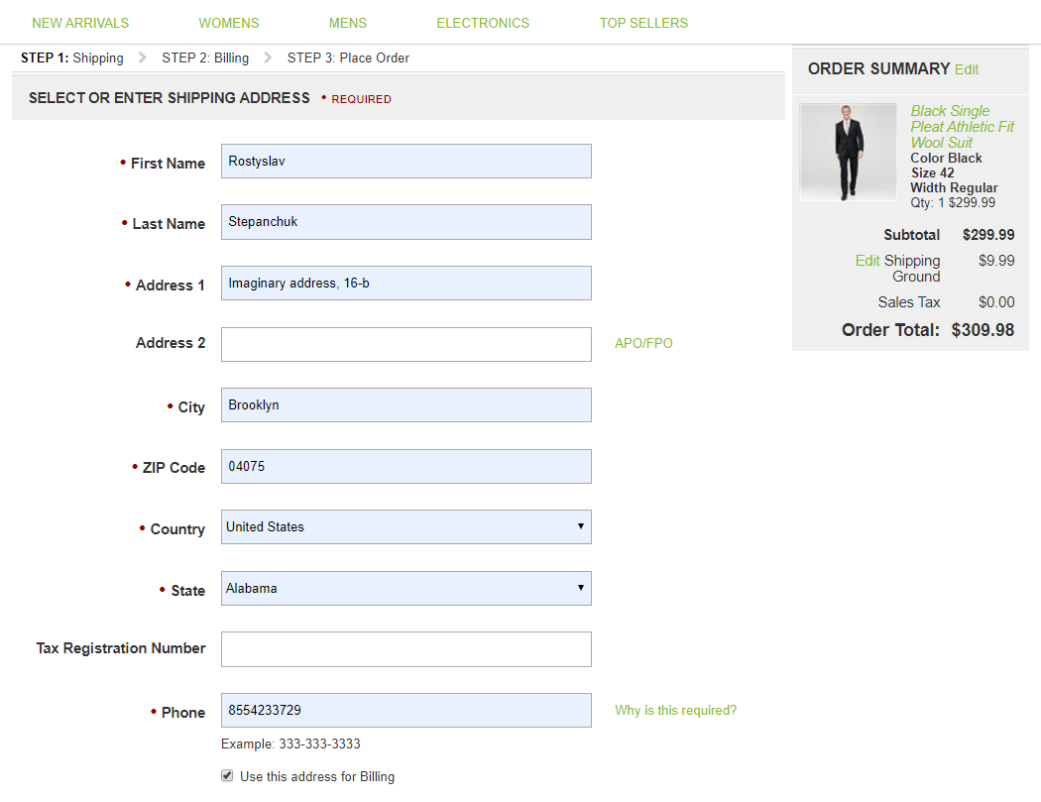

When you click on CONTINUE TO BILLING button, after some time you’ll receive One of two messages:
Either major address error notification

Or notification with couple of options to finalize address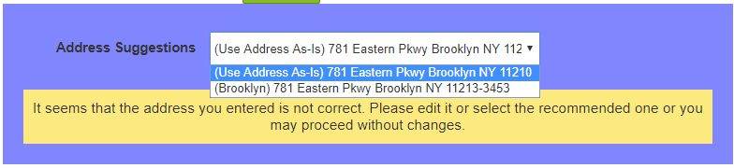

When you reached next (payment) stage, go back to business manager:
Administration>Site Development>Development Setup
Then go to log files
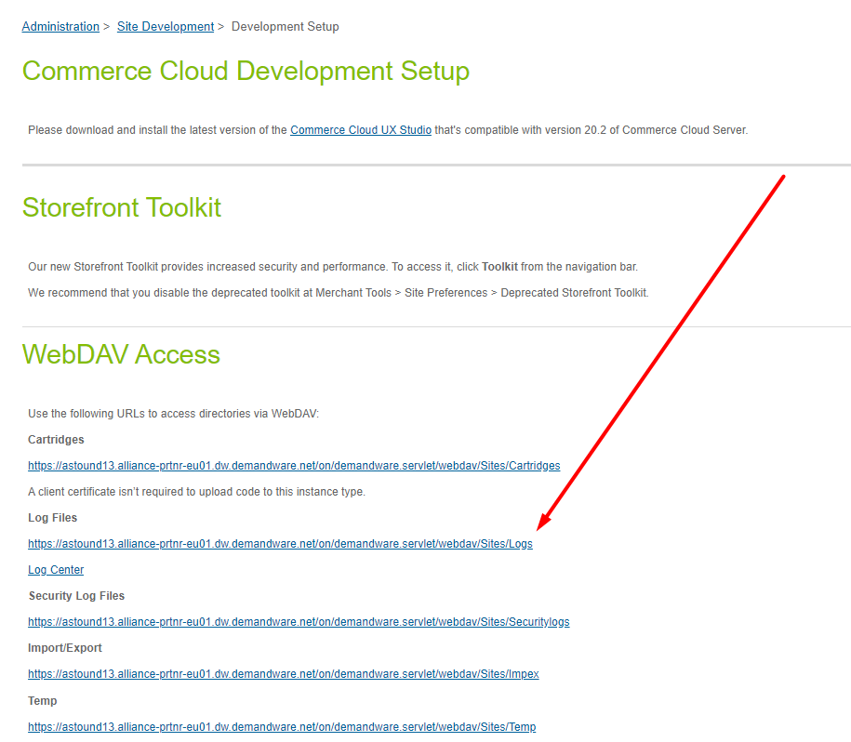

Find VertexSOAP blade, it has SERVICE tag.
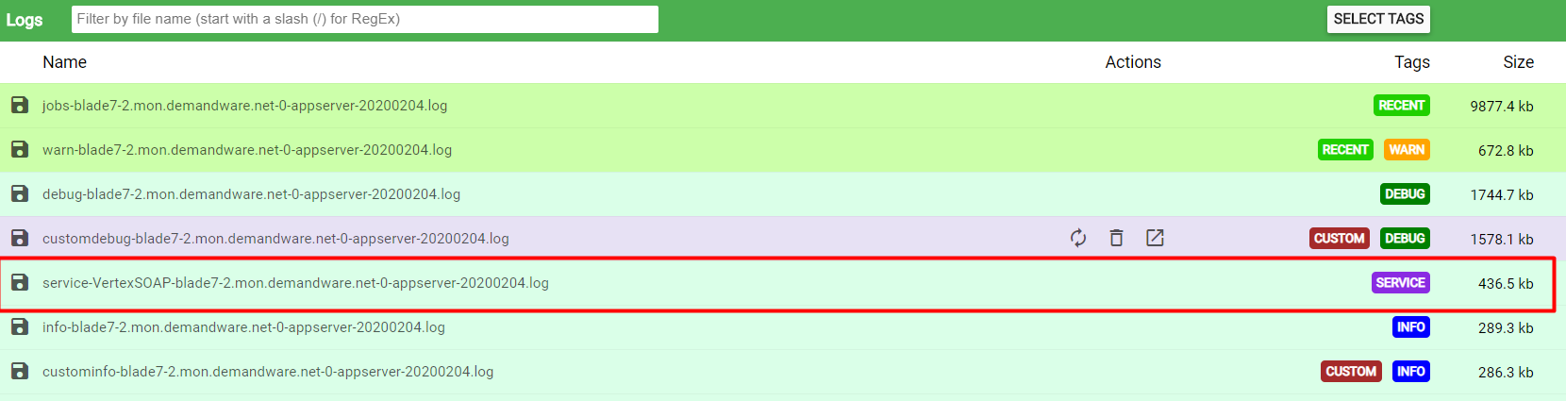

Find INFO statement with Response object. Compare total and totalTax data with the one you have in order summary on storefront checkout page
